Solution: Entity Names

In this lab, you will use the Entity Name editor to create an entity name.

Requirements

This lab requires that you first complete labs from previous lessons including Creating Entities, Typelists, Editable List View Panels, and Create new objects with Popups.

This lab requires that you use TrainingApp 8.0, Guidewire Studio 8.0, and a supported web browser. To view, edit, and delete various contacts, log in to TrainingApp as Alice Applegate. The default URL for TrainingApp is <http://localhost:8880/ab/ContactManager.do>. The login/password for Alice Applegate is aapplegate/gw.

1. Create an Entity Name

In this exercise, you will use the Entity Name editor to define a default name for the Interaction_Ext entity.

Part A

In Part A of this exercise, you will create the entity name for the Interaction_Ext entity.

Configuration

1. Open Guidewire Studio for TrainingApp
2. From Studio, if your server is not already running, start the server using Debug 'Server'.
3. Review the Debug console for errors and verify that the application is running in the Debug console.
4. Create the Interaction_Ext entity name
5. In Project view, create a new entity name for the Interaction_Ext entity named Interaction_Ext.

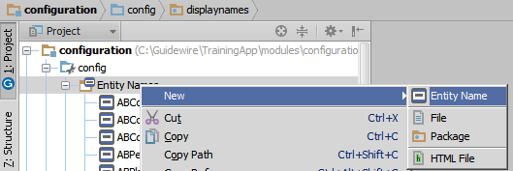

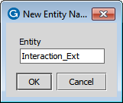

1. Create variables in the variable table
2. Add the interactionDate variable with the entity path Interaction_Ext.InteractionDate.
3. Add the channel variable with the entity path Interaction_Ext.Channel.
4. Define the Default name
5. For the Default name, return a string that includes the interactionDate and channel variables in the following format:
   * YYYY-MM-DD : ChannelType
6. If the date is null, then return the following:
   * (No Date) : Channel Type
7. If the date is more than one (1) day in the future, then return the following:
   * (# days in the future) YYYY-MM-DD : ChannelType

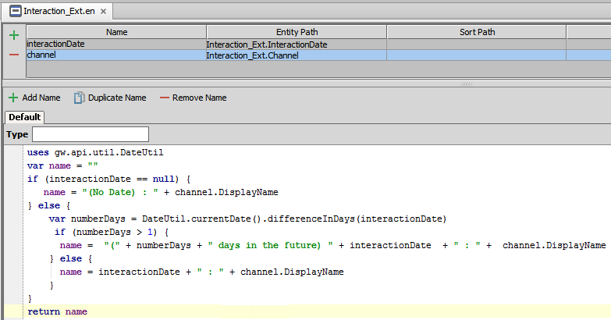

1. Deploy your changes
2. In Studio, restart the server to deploy the new entity name.

Part B

In Part B of this exercise, you will modify the InteractionsLV.pcf file to display the entity name.

Configuration

1. Modify the InteractionsLV.pcf
2. Open the InteractionsLV.pcf file in Studio.
3. Change the Date Cell widget to a Text Cell widget.

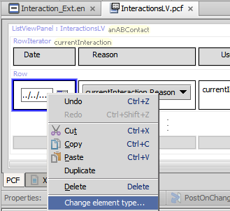

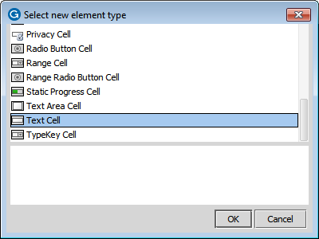

1. Configure the Text Cell widget to …
   * be read-only
   * show the new Interaction_Ext entity name for the currentInteraction object

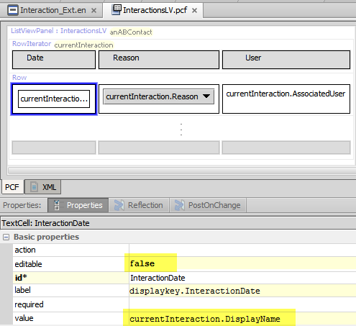

uses gw.api.util.DateUtil

var name = ""

if (interactionDate == null) {

name = "(No Date) : " + channel.DisplayName

} else {

var numberDays = DateUtil.currentDate().differenceInDays(interactionDate)

if (numberDays > 1) {

name = "(" + numberDays + " days in the future) " + interactionDate + " : " + channel.DisplayName

} else {

name = interactionDate + " : " + channel.DisplayName

}

}

return name

Verification

You will verify the deployment of the new entity name and your configuration changes.

1. Log in to TrainingApp
2. Log in as Alice Applegate.
3. Reload the PCF changes
4. In TrainingApp, reload the PCF file changes.
5. Edit the Interactions page for William Andy
6. Open the William Andy contact.
7. In the sidebar menu, click Interactions.
8. Create an interaction in the future.
   * Enter a Date that is more than one (1) day in the future , select a Channel Type, select a User, and select a Reason.
9. Create an interaction with no interaction date.
   * Leave the Date field blank, select a Channel Type, select a User, and select a Reason.
10. If you did not create one or more previous interactions from an earlier lab, create at least one more interaction.
    * Enter today's date for the Date, select a Channel Type, select a User, and select a Reason.

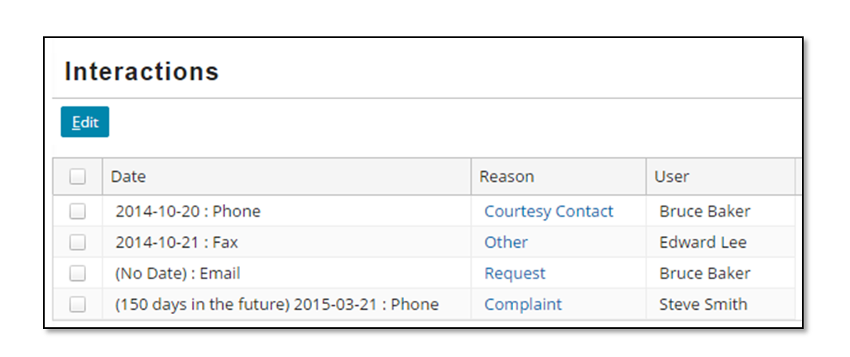

|  |  |
| --- | --- |
|  | Stop and ask your instructor to review your completed lab. |